**Practical No.07**

**Python and MongoDB**

**Q.1]Connecting Python with MongoDB and inserting, retrieving, updating and**

**deleting.**

**Inserting data:**

**1] insertOne():**

import pymongo

db=pymongo.MongoClient("mongodb://localhost:27017")

studdb=db.sk

studcol=studdb.student

myd={"Roll No":1,"Name":"abc","Age":20}

studcol.insert_one(myd)

print("Inserted One...")

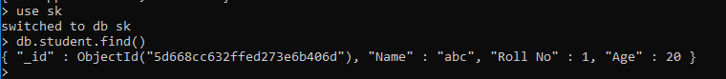

**2] inserted many():**

import pymongo

db=pymongo.MongoClient("mongodb://localhost:27017")

studdb=db.sk

studcol=studdb.student

myd=[{"Roll No":2,"Name":"def","Age":21},

{"Roll No":3,"Name":"ghi","Age":22},

{"Roll No":4,"Name":"jkl","Age":23},

{"Roll No":5,"Name":"mno","Age":24]

studcol.insert_many(myd)

print("Inserted Many...")

 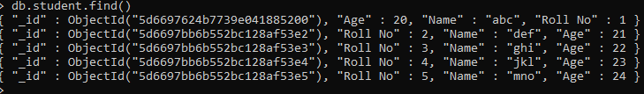

**Retrieving data:**

**1] FindOne():**

import pymongo

db=pymongo.MongoClient("mongodb://localhost:27017")

studdb=db.sk

studcol=studdb.student

c=studcol.find_one()

print(c)



**2] Find many():**

import pymongo

db=pymongo.MongoClient("mongodb://localhost:27017")

studdb=db.sk

studcol=studdb.student

c=studcol.find()

for i in c:

print(i)

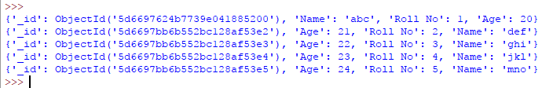

**Update data:**

**1] update one():**

import pymongo

db=pymongo.MongoClient("mongodb://localhost:27017")

studdb=db.sk

studcol=studdb.student

studcol.update_one({"name":"abc"},{"$set":{"name":"xyz"}})

print("Updated...")

 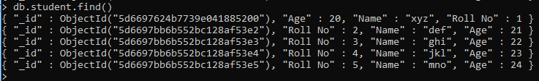

**2 ] updated many():**

import pymongo

db=pymongo.MongoClient("mongodb://localhost:27017")

studdb=db.sk

studcol=studdb.student

studcol.update_many({},{"$set":{"name":"PUBG"}})

print("Updated Many...")

 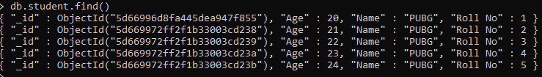

**Delete data:**

**1] Delete one():**

import pymongo

db=pymongo.MongoClient("mongodb://localhost:27017")

studdb=db.sk

studcol=studdb.student

studcol.delete_one({"Roll No":"1"})

print("Deleted One...")

 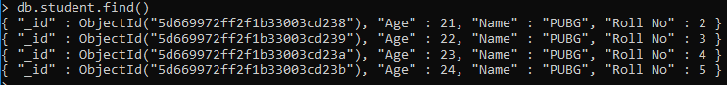

**2] Delete many():**

import pymongo

db=pymongo.MongoClient("mongodb://localhost:27017")

studdb=db.sk

studcol=studdb.student

studcol.remove({})

print("Deleted...")

 